[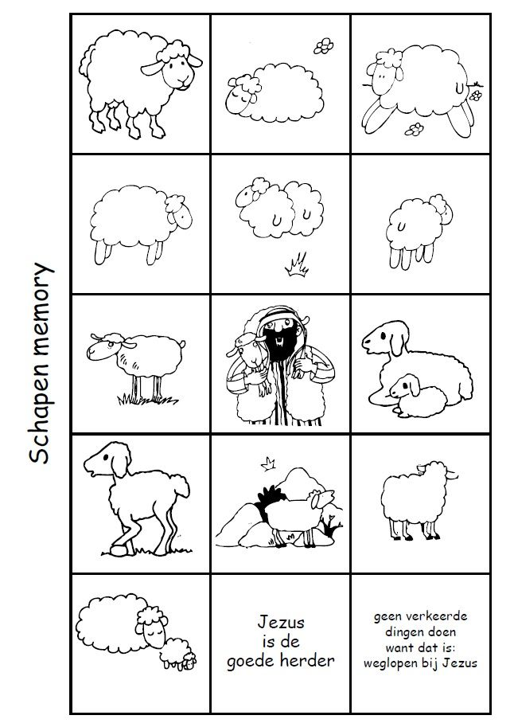](https://www.google.com/url?sa=i&url=https%3A%2F%2Fwww.pinterest.com%2Fpin%2F472315079660303223%2F&psig=AOvVaw0q4q-_oQPjO46PqCytdvbQ&ust=1587715562462000&source=images&cd=vfe&ved=0CAIQjRxqFwoTCNikhMiL_ugCFQAAAAAdAAAAABAW)

[](https://www.google.com/url?sa=i&url=https%3A%2F%2Fwww.pinterest.com%2Fpin%2F472315079660303223%2F&psig=AOvVaw0q4q-_oQPjO46PqCytdvbQ&ust=1587715562462000&source=images&cd=vfe&ved=0CAIQjRxqFwoTCNikhMiL_ugCFQAAAAAdAAAAABAW)